||JAI SRI GURUDEV||
S.J.C. Institute of Technology, Chickballapur.
Department of Artificial Intelligence and Data Science
ASSIGNMENT & TUTORIALS - 2
Subject Name & Code: NATURAL LANGUAGE PROCESSING (BAD613B)

Semester: VI DATE: 12/04/2025
- Write a note on different phrase level constructs with suitable example for each phrase.
- Derive a top-down depth first algorithm for the following sentence; “ The angry bear chased the frightened little squirrel”..
- Write CYK parsing algorithm. Find the sequence of states created by CYK algorithm while parsing the sentence: ”The man read this”. Consider the following simplified grammar in CNF.
SNP VP Det that|this|a|the
S VP Noun book |flight|meal|man
VP Verb NP Verb include|read
NP Det Noun Aux does
- Design CYK algorithm. Tabulate the sequence of states created by CYK algorithm while parsing the sentence, “A pilot like flying planes”. Consider the following simplified grammar in CNF
S -> NP VP NN -> Pilot VBG -> flying
NP -> DT NN NNS -> plane JJ -> flying
NP -> JJ NNS VP -> VBG NNS Det -> a
VP -> VBZ NP VBZ -> likes
- Explain context-free grammar, with an suitable examples.
- A Naive Bayes text classifier has to decide whether the document ‘Chennai Hyderabad’ is about India (class India) or about England (class England). Estimate the probabilities that are needed for this decision from the following document collection using Maximum Likelihood estimation (no smoothing). 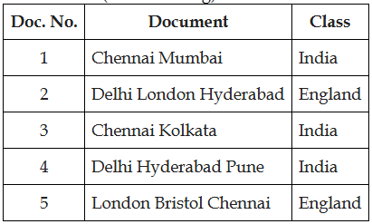
- Assume the following likelihoods for each word being part of a positive or negative movie review, and equal prior probabilities for each class

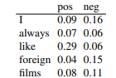

What class will Naive bayes assign to the sentence “I always like foreign films.”?
- Given the following short movie reviews, each labeled with a genre, either comedy or action: 1. fun, couple, love, love comedy
2. fast, furious, shoot action
3. couple, fly, fast, fun, fun comedy
4. furious, shoot, shoot, fun action
5. fly, fast, shoot, love action
and a new document D:
fast, couple, shoot, fly
compute the most likely class for D. Assume a naive Bayes classifier and use add-1 smoothing for the likelihoods.
- Explain optimizing for Sentiment analysis.
- Discus briefly on Training the Naïve Bayes Classifier.
- Illustrate a Multinomial Naïve Bayes Classifiers
- Define parsing, explain bottom-up paring with a suitable example.
- Refer the class notes problems.

